Connections ONLINE 4.X
MICROSOFT Outlook 2013 (and later) CONNECTOR User GUIDE

Table of Contents
Introduction to Outlook and Connections Online 3
Overview 3
Microsoft Outlook 2010 3
System Requirements 3
Deleting 4
Creating Tasks and Events in Outlook 4
Installation 5
Configuration 6
Login 6
Settings 7
Menu Options 7
Synchronizing with Connections Online 8
Identifying Connections Online Items in Outlook 8
Tasks 8
What Are Tasks? 8
Data Map 9
Using Tasks 10
Marking a Task Complete 11
Events 11
What Are Events? 11
Data Map 12
Using Events 13
Synchronizing Updates in Connections Online 13

Introduction to Outlook and Connections Online
Individuals use Outlook to help organize and prioritize their work.
Organizations use Connections Online to help organize and prioritize how work and resources are used by teams and individuals.
You can now sync Connections Online and Outlook. This makes for a very powerful tool, quickly aligning individuals and teams with the organization.

Overview
The Outlook Connector provides a bridge between Connections Online and Microsoft Outlook. Users can edit and mark tasks completed. They can see and reschedule dialogs or project end dates. The following items from Connections Online are available to the connector:
- Project Tasks
- Personal Tasks
- Basic Role Tasks
- Dialog Follow-up Tasks
- Individual Dialogs
- Project Dialogs
- Department/Organization Dialogs
- Project End Dates
The criteria used to determine which items are synchronized for a particular user is explained in more detail throughout this document. It is important to note before starting that Connections Online security is enforced for all items.

Microsoft Outlook 2010
The Microsoft Outlook 2010 Connector is no longer updated and has limited support due the age of the product. It is recommended that users upgrade to Microsoft Outlook 2013 or 2016. Both of these versions will work with the 2013 Connector.

System Requirements
The following must be available before using the Microsoft Outlook Connector:
- Outlook 2013 (or later)
- Subscription and login to Connections Online 4.0 or 4.1
- High speed internet connection
- The Outlook Connector must be installed on your desktop to be able to sync with Connections Online.

During installation of the connector, the following libraries will be installed if they are not already on the target machine:
- .NET 4.5 Client Profile
- Visual Studio Tools for Office Runtime

Deleting
Calendar items that are deleted in Outlook will not be deleted in Connections Online. As a result, on the next synchronization, they will be recreated in Outlook if they still fit the criteria for synchronization explained later in this document. When tasks are deleted in Outlook, a prompt will appear asking the user if the task should be deleted in Connections Online as well. If the user selects “Yes”, the task will be deleted in Outlook and in Connections Online. If the user selects “No”, the task will only be deleted in Outlook, and will reappear on the next full synchronization.

Creating Tasks and Events in Outlook
The Outlook Connector does not support creating new items for import into Connections Online. All tasks, dialogs, and projects must be created in Connections Online.

Installation
These installation instructions may vary slightly based on the type of web browser used and the version of Microsoft Windows that is being run.
Note: The Microsoft Outlook connector feature needs to be enabled in Connections Online before it can be used. If this has not occurred, or an error is received that it is not enabled, please contact Connections Online.
- Currently, the connector can be downloaded from this forum post: Outlook Connector. Please note that the Microsoft Outlook 2010 Connector is no longer available.
- Save this file to the local hard drive.
- Once saved, double-click (or right-click and select “Open”) on the COLOL2013.exe (or COLOL2013_x64.exe) file to self-extract the installer.
- Double-click (or right-click and select “Open”) on the COLOL2013Install.exe file to install the connector.
- On the first window of the “Connections Online Outlook 2013 Connector Setup”, read the License Agreement. Check “I agree to the license terms and conditions” and click Install to continue, or Cancel to exit.
- A security warning may display from Windows asking if you wish to allow the program to make changes on your computer. Click Yes to continue installation, or No to cancel.
- Click Close once installation is complete.

Configuration
This section explains the options available for the connector in the configuration and the menu. The user must complete the Login process before using the connector to synchronize with Connections Online.

Login
- Open Microsoft Outlook 2013 or later.
- Go to File->Options.
- Click Add-Ins to see a list of the installed Add-Ins.
- Verify that the Connections Online Outlook 2013 Connector is listed under Active Application Add-ins. If it is not listed, please try installation again.
- Click the Add-in Options button at the top to get to the Add-in Options configuration window.
- Select the Connections Online tab. The options are shown below.
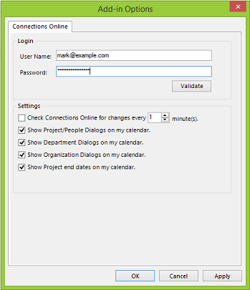
- In the Login box, type in a valid Connections Online user login and password. This is the same login used to access the Connections Online application.
- Click the Validate button. A message will display indicating if the login is successful or not.
- Click OK to save the Login or Apply to save without closing the window.

Settings
The following settings are available in the Add-in Options:
- Check Connections Online for changes every X minute(s) – This option allows Outlook to synchronize with Connections Online automatically every X minute(s). If it is unchecked, synchronizations are done manually via the Connections Online add-in menu discussed in the next section. This option does an update synchronization meaning it updates items based on last change dates from Connections Online and Outlook. It is equivalent to the “Synchronize Updates” menu option. Synchronization is completed in the background and will not be visible to the user, but it may cause conflicts if the user just happens to edit an item that is being synchronized. This is rare but can cause a locking error if it happens.
- Show Project/People Dialogs on my Calendar – This option will add dialogs for the user either from the Individual page or from any project on which he or she is a team member. Users must have security to the dialogs for them to synchronize. Dialogs are set for 1 hour by default.
- Show Department Dialogs on my Calendar – This option will include all dialogs for any department a user is associated including both primary and secondary relationships. Users must have security to the dialogs for them to synchronize. Dialogs are set for 1 hour by default.
- Show Organization Dialogs on my Calendar – This option will include all organization dialogs. Users must have security to the dialogs for them to synchronize. Dialogs are set for 1 hour by default.
- Show Project End Dates on my Calendar -- Check this option to include project end dates on which the user is a team member. Location is set to “Project End Date” for easy identification in Outlook.

Menu Options
The add-in menu options are available at the top of Outlook 2013 under the Add-ins tab, Connections Online menu.
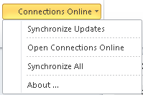
- Synchronize Updates – Items in Outlook will be synchronized with Connections Online based on last change date. Items that have been deleted in Outlook will not be recreated with this option.
- Open Connections Online – Opens Connections Online in the default web browser.
- Synchronize All – All tasks and events in Connections Online will be synchronized to Outlook. This means that the current data in Connections Online will now be current in Outlook regardless of last change dates. This option overwrites any changes that may have been made in Outlook that were not saved to Connections Online, i.e. deleted items. Use this option to force Outlook to match Connections Online.
- About – displays version information for the Outlook Connector.

Synchronizing with Connections Online
After installing the connector, it is recommended that users run a Synchronize All command from the menu to force a full synchronization to Outlook from Connections Online. This provides a good starting point where both systems are completely synchronized. The user may also wait for the auto-sync to work as well.

Identifying Connections Online Items in Outlook
Every task, dialog, and project end date that is synchronized to Outlook will have a Category of “Connections Online”. The Category is typically displayed by default in Outlook but can be added to the List view by right-clicking a column header and using the “Field Chooser…” option. Items will also have additional information during edit as explained in the following sections.
On systems where the Connections Online user changes in Outlook, the category will change to “Connections Online – Disconnected” for all items associated with the previous login so that synchronizations no longer occur. This is to prevent data loss. A situation where this may occur is when a PC may be passed to a new employee without a clean install or if multiple users are being used to test the Outlook Connector. Items that are disconnected may be deleted without affecting Connections Online.

Tasks
This section explains how tasks are imported from Connections Online into Outlook and how their fields map between the two applications.

What Are Tasks?
Tasks that are pulled from Connections Online include any type of task to which the user is assigned. This includes:
- Basic Role Tasks – This includes tasks that are active or that have been completed in the last 30 days.
- Dialog Follow-up Tasks – For individual, organization, and department dialogs, this includes tasks that are active or that were completed in the last 30 days. For project dialogs, this includes tasks for active projects or projects that have been completed in the last year.
- Personal Tasks – This includes tasks that are active or that have been completed in the last 30 days.
- Project Tasks – This includes tasks from active projects or projects that have been completed in the last year.
Tasks can be seen in List form by going to the Tasks option in the left navigation pane. Some properties of a task can be edited directly in this list by double-clicking the column to edit or checking the Completed or Status column. Those changes will be synchronized to Connections Online immediately.
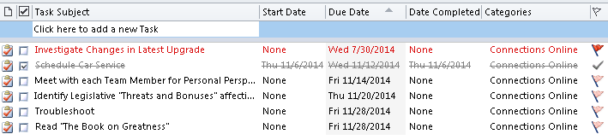

Data Map
Data is mapped to Connections Online as follows:
Connections Online Task Field | Outlook Task Field
Name | Subject
Description | Body
Actual Start Date | Start Date
Actual End Date | Completed Date
Projected End Date | Date Completed
Projected Start Date | Projected Start Date (Custom Field)
Priority | Importance
Actual Hours | Actual Work
Projected Hours | Total Work

Using Tasks
Tasks can be updated in Outlook in the list view or by opening the edit window. Any changes made will be saved to Connections Online immediately. The screen below shows a Connections Online task opened for edit.
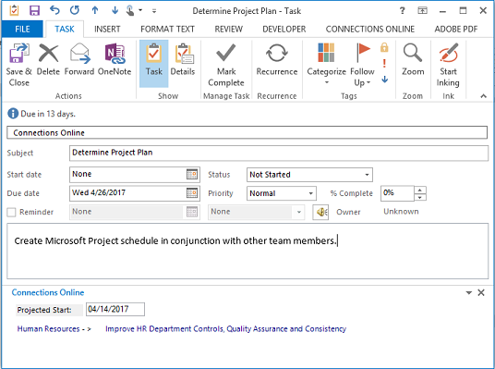
The Category of “Connections Online” is shown at the top of the form. At the bottom, there is a custom panel, titled “Connections Online”, which shows the projected start date for a task and also links to the ancestors of the task in Connections Online. Changes to the projected start will be saved just as any of the Outlook fields above. This example window shows task “Determine Project Plan” from the Improve HR Department Controls, Quality Assurance, and Consistency Project for the Human Resources Department. It is projected to start on 4/14/2017 and end on 4/26/2017. It has normal priority. The description is shown in the white box “Create Microsoft Project schedule…”
Once the user has made changes on this window, he or she must click “Save and Close” to synchronize the changes to Connections Online.

Marking a Task Complete
The most common task in the connector is marking tasks complete. To do this, simply mark the task complete in Outlook and it will synchronize back to Connections Online. There are several ways to mark a task complete in Outlook:
- Complete Column - In the List view, users can click the checkmark in the Complete column to toggle the completed status next to each task. This column is shown by default, but if it is missing, it can be shown by right-clicking a column header and selecting “Field Chooser…” Date Completed will be updated to the current date and send back to Connections Online as the actual end date.
- Status – In the List view Status column, users can right-click the icon and select “Mark Complete”. As noted above, if the Status column is not displayed, use the “Field Chooser…” to add it to the view. Status is also offered on the edit window for the task. Selected “Completed” in the dropdown and press Save. Date Completed will be updated to the current date and send back to Connections Online as the actual end date.
- % Complete – Edit the task and set the % Complete to 100%. Date Completed will be updated to the current date and send back to Connections Online as the actual end date on save.
- Date Completed – In the List, set the Date Completed field to a date. This date will update the actual end date in Connections Online.

Events
This section explains how dialogs and project end dates are imported to Outlook and where to find Connections Online data associated with these items.

What Are Events?
Connections Online dialogs and projects end dates are considered events in the connector. They are imported to Outlook in the form of Appointments on the Calendar. Appointments items are made for 1 hour by default. Here is the criteria for events:
- Individual Dialogs – All dialogs for the current user that are scheduled for the next 1 year period.
- Department and Organization Dialogs – All dialogs for departments and organizations that the user is associated with, both primary and secondary. Dialogs may be scheduled for up to 1 year.
- Project Dialogs – All dialogs for projects on which the user is a team member and that are scheduled in the next 1 year period.
- Project End Dates – This includes any project that the user is a team member on and that is not completed. The date shown is the projected end date. Appointments for project end dates are scheduled for 8am to 9am. The Location for project end dates always reads “Project End Date”.
Dialogs and project end dates can be viewed in the List view or on the Calendar in Outlook. Use the Calendar option in the navigation pane on the left in Outlook. The following screen shows an example list of events for a user. Note that they are grouped by Category so the user can easily see which ones are from Connections Online.
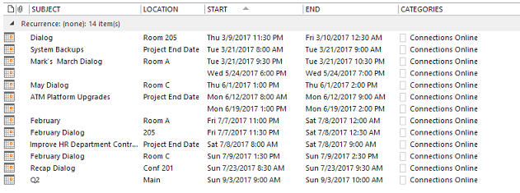
Note: Items with blank Subject/Locations are Dialogs entered in Connections Online without Name and Location entered.

Data Map
Data is mapped to Connections Online as follows:
Connections Online Project/Dialog Field | Outlook Appointment Field
Name | Subject
Description | Body
Location | Location (Dialogs)  “Project End Date” for Projects
Dialog Date (Dialogs) | Start Time (Dialogs)
Projected End Date (Projects) | Start Time (Projects) – time set 8-9am.

Using Events
In Outlook, dialogs and projects can be updated. The following screen shows a Connections Online dialog in Outlook.
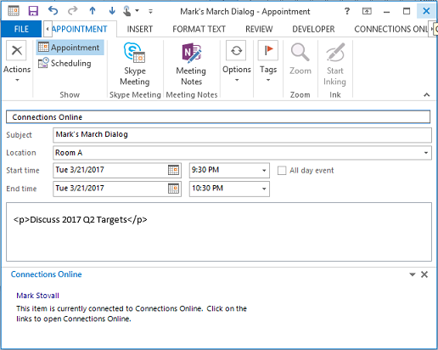
Just like the tasks, the first box on an appointment edit window shows the category. For Connections Online items, this will display “Connections Online”. At the bottom of the edit window, there is a panel with a link to the associated item in Connections Online. In the above example, “Mark’s March Dialog” for 3/21/2017 is shown. The link “Mark Stovall” in the bottom panel will open Mark’s individual page in Connections Online. For dialogs, users can update the name, location, description, and dialog date (start time) in Outlook and it will be saved back to Connections Online. For projects, users can update the name, description, and projected end date (start time) in Outlook for change in Connections Online.
Once the user has made changes on this window, he or she must click “Save and Close” to synchronize the changes to Connections Online.

Synchronizing Updates in Connections Online
Changes that are made in Connections Online are only synchronized to Outlook during a Synchronization cycle. As explained in previous sections, this is done when the auto-synchronization process runs every X minutes, or when the user selects the “Synchronize Updates” or “Synchronize All” options. For “Synchronize Updates”, only the latest changes will be synchronized. With this option, deleted items will not reappear in Outlook if they were not deleted in Connections Online. For “Synchronize All”, data from Connections Online will overwrite data in Outlook.

