Logging into Connections Online with Facebook and Twitter

Introduction
Connections Online 4.1 now supports the ability for Users to log in using their Facebook or Twitter accounts. This functionality can be enabled or disabled through Site Administration settings. The first time Users log in with either method they will complete some simple steps linking their accounts to Facebook or Twitter. After this, the authentication will be almost invisible to the User. It is important to note that Connections Online does not post or share any information on Facebook or Twitter. It is merely asking for authentication from those sites and allowing access to Connections Online accordingly.

Getting Started
The first step to use Facebook or Twitter authentication is to enable the options in the Site Administration page. This is done by navigating to Site Administration and clicking the Single Sign-on (SSO) tab on the right side of the screen. At the bottom of the page, there is a section titled "Other Login Options" as shown below. Check "Allow Facebook Login" or "Allow Twitter Login" to enable these features for the site. Press the "Save" button at the bottom to save the changes.
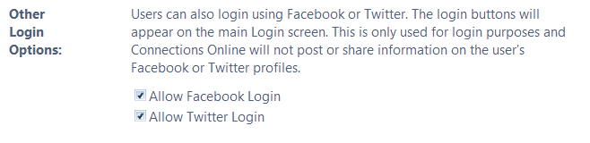
Before users can proceed, it is also important that Twitter and/or Facebook are not blocked from internal access. If the site is blocked, it will not allow them to authenticate.
Please note that the Facebook and Twitter Sign In buttons will show on the Login page (as shown on the next page) whether these features are enabled or not. This is due to the inability of Connections Online to determine which site Users are logging into until they actually log in. If the features are not enabled, when Users attempt to link their accounts as described in the following sections, it will show them an error and let them go back to the Login page.

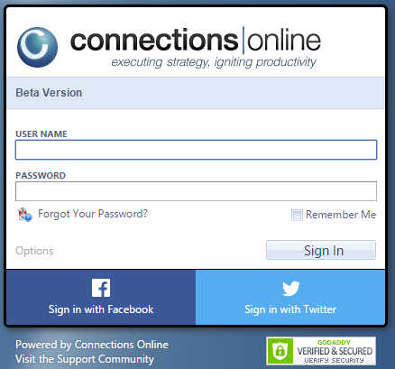

Logging in with Facebook
Once the Site has been enabled for Facebook login, Users can click the "Sign in with Facebook" button on the main Login screen. The first thing that will happen is that the application will contact Facebook for authentication. If Users are not logged into Facebook, they will be prompted to do so and will be asked to allow Connections Online to access their profile. If they are already logged in, they will be prompted to allow Connections Online access. Once this step is complete, they will no longer need to do this step unless they remove the Connections Online app in Facebook and/or they log out of Facebook.
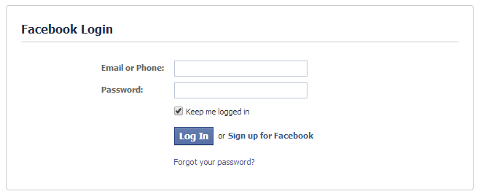
To cancel out of the Facebook login, Users can use the Back button to the Login page in Connections Online 4.1 so they may proceed with their standard username and password. Upon successful login to Facebook, users will be returned to Connections Online 4.1 and asked to link their account, if they have not done so previously. Linking the account is done by entering their Connections Online 4.1 username and password in the prompt as shown below. Users may cancel the process at this point by clicking the Cancel link to return to the main Login page.
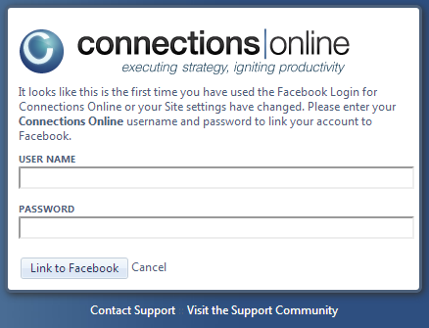
At this point in the process, if the Site has disabled Facebook login, the user will be shown an error and given options to return to the Login page or contact support. This will also happen if the Site setting was changed since the initial link was done.
Once the account has been successfully linked, Users will not have to go through the Linking process again unless they get a new Facebook account.

Logging in with Twitter
The Twitter login is the same as the Facebook process. Users can click the “Sign in with Twitter” button on the main Login page. On the first attempt, they will be prompted by Twitter to authorize the ConnectionsOnline.net app. If they have previously completed this step, they will see a brief screen indicating Twitter is authorizing them, and then they will be logged into Connections Online 4.1.
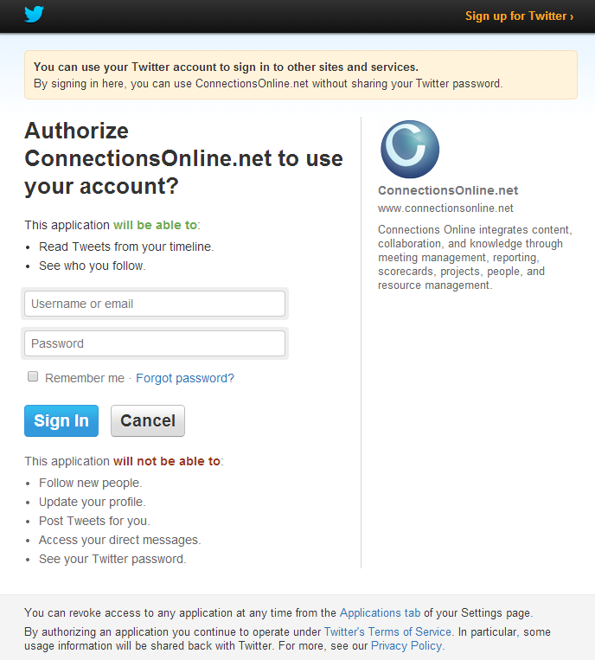

Users can press "Cancel" to return to the Connections Online 4.1 Login screen. Otherwise, upon Sign in, Users will be returned to the application where they will then link their Connections Online 4.1 account to their Twitter profile. To do so, Users will enter their Connections Online username and password and click the "Link to Twitter" button. If Users wish to cancel this process, they will click the "Cancel" link to return to the Connections Online login screen.
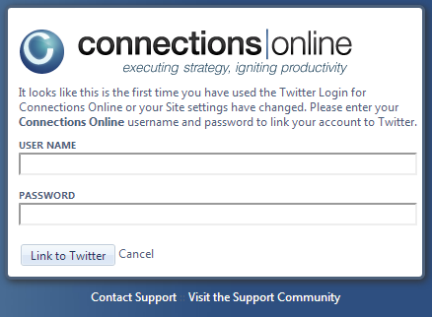

At this point in the process, if the Site has disabled Twitter login, the User will be shown an error and given options to return to the Login page or contact support. This will also happen if the Site setting was changed since the initial link was done.
Once the account has been successfully linked, Users will not have to go through the Linking process again unless they get a new Twitter account.

Revoke Facebook Authorization
In the steps above, authorization privileges are granted to the Facebook Connections Online app. To undo this authorization, Users can follow the following steps in Facebook:
1. Log in to Facebook
2. Locate the App in the left side bar under Apps. Use the "More" option if the Connections Online app is not showing.
3. Click the Edit pencil next to the "Connections Online" app and select "Remove App".
4. Confirm removal.

Revoke Twitter Authorization
To undo User authorization of the Twitter ConnectionsOnline.net application, Users can follow the following steps in Twitter:
1. Log in to Twitter
2. Go to the "Settings and Help" gear icon in the top right corner.
3. Select "Edit Profile"
4. Select "Apps" in the left sidebar.
5. On the right, click the "Revoke Access" button next to the ConnectionsOnline.net application

