Built-In File Sharing (powered by Secure Sypher)
Sites now have an option to allow Users to upload files as Related Links. This feature was previously sold separately through the Secure Sypher product, but it is now included at no additional charge with every Connections Online account.

How to Enable File Uploads
To enable file uploads for your site, log in as a site administrator and go to the Site Admin page. From there, choose the File Uploads tab. Then, simply click the Enable Uploads button.
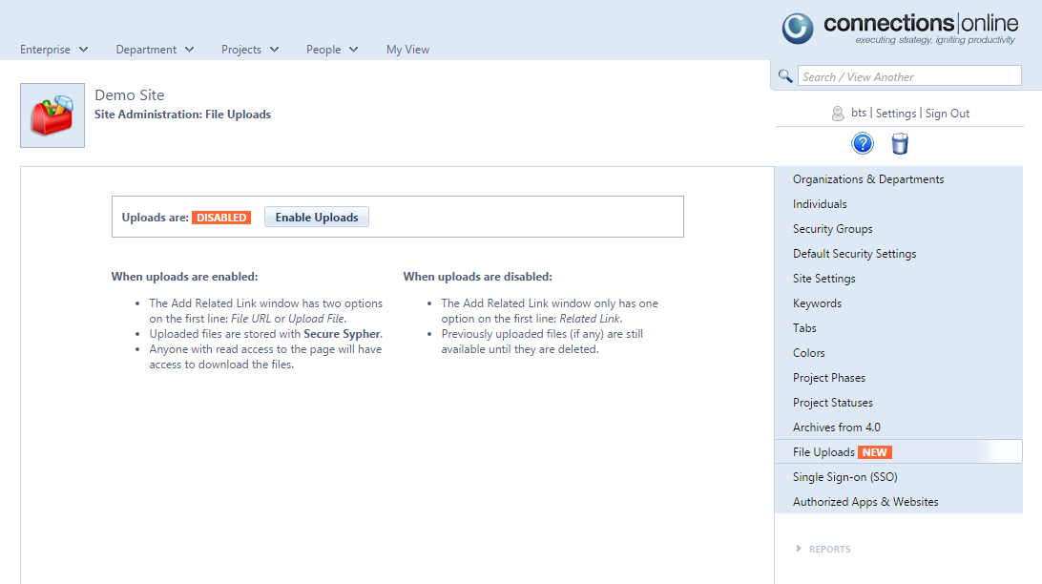

Once enabled, the Related Links module will show the new Upload File option when any User is adding a new Related Link.

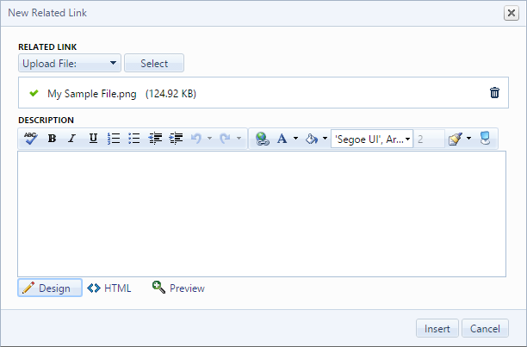

How to Disable File Uploads
To disable file uploads for your site, log in as a site administrator and go to the Site Admin page. From there, choose the File Uploads tab. Then, simply click the Disable Uploads button.
If the feature is disabled after files are uploaded, the files will continue to be available for download, but the upload option will no longer be visible for new Related Links.

