Quick Reference Guide - Connections Online Version 4.1

Connections Online User Manual: https://files.connectionsonline.net/files/Manuals/User-Manual-Version-4-1.pdf

The technical requirements are a web browser: IE8 or higher (not IE7), Firefox 3#, Chrome 10#, and other new web standard browsers.
Logging in – Use the http://COL.connectionsonline.net Interface. You will see a login screen – just enter your user name and password.
On the Login screen, input your User ID and password.
- User ID = email address
- Password = this will be provided to you by IT or use the “forget password” link (a temporary password only lasting one hour – so you must change it before the hours is up)
- Remember Me - To save Connections Online as a favorite:
  - At login screen, select “Favorites” from the menu.
  - Select “Add to Favorites” and click on “OK”
  - Next time you login, click “Remember Me” and you will automatically log into the program.

Additional Notes:
- User ID is not case sensitive, Password is case sensitive.
- To change your password, when you first login, click your login ID showing in the upper right of your screen, then click the “Change Password” button, change your password and click “Update Password” to save.
- Please note: screen shots and videos in this document represent the “default” settings for the application. Module header names, tab names, and other terms can be changed to represent the nomenclature unique to that of the customer.

The following are highlights of the Version 4.1 interface:
Navigation of the tabs: the list of places you have visited is now accessed by clicking the down arrow next to the tab title. You will then see the list of places you have recently visited. You will need to use the search feature to navigate to other pages in the application, which you will find on the right side of the page – the icon of a magnifying glass will now be the feature you use to view other tabs.
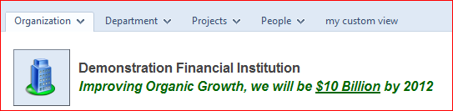
Search (View Another): use the magnifying glass in the upper right corner to search for the Orgs, Depts, Projects, and People you want to view. Once viewed, it will appear on the list under the tab. To search, click on the search icon and a box opens; select the icon on the left of the box representing Orgs, Depts, Projects, People, etc. Once you select the icon/type of list you want to view, the box will “fill” with the search information you have requested. Click on the link (from the list) for the tab you want to see.
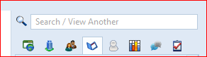
Editing in General: All editing will be done as a “quick edit expand” or a full page of the item and you can edit it from there.

Adding, Editing, or Deleting Data
Each data module (Main Column or Sidebar) for each page uses the following edit symbols, which the User (with proper security) will use to add, edit, or delete data.
Colored Text Link: These links can open an item to edit, or navigate to an item in a different tab. The User can use the cursor to hover over the data item – it will “turn blue” to show that it is a hyperlink. If the User clicks on the link, the item will open in a new tab for more detail. Or it will open the item’s edit screen – whichever is appropriate.
Click to show details for metrics, projects and tasks Click to hide details
Pencil Symbol: Click this symbol to EDIT the element next to it.
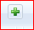 The Add Symbol: Click this symbol to ADD new data. Once the data has been entered into the quick entry fields and updated, click on the link to the new item and it opens into a full page where further editing can be done.
The Delete Symbol: Click this symbol to DELETE an item. This is typically found at the end of the row naming the item you want to delete. In most cases you will be asked to confirm the deletion.
Drag and Drop: Users can adjust the order of the information by grabbing the drag/drop symbol and move the item up or down, in or out. When you drag the red line shows where it will be inserted (under the red line).
- Drag over the bottom half of 4 to drop as 5
- Drag over 4 and hold SHIFT to drop as 4.1, or drag over the top half of 4.1 to drop as 4.1
- Drag over the bottom half of 4.1 to drop as 4.2
- Drag over 4.1 and hold SHIFT to drop as 4.1.1
- Since you are dragging 4.2 in the example, dropping on 4.2 does nothing
Archive: A User can view archived metrics or projects by clicking the archive symbol on the title bar for metrics or projects module.
Create, Copy or Link Projects or Metrics: Click the green plus sign and you will get the options of User can copy metrics and projects within an organization or department and people pages – or copy one metric or project to another organization, department, or people tab.
Undelete Symbol: Click this symbol, found at the upper right of the page, and you will open an “Undelete” page listing deleted items. Roll over the item you want to undelete and click on the undelete symbol to the left of the item. Navigate back to the original page and the item will be restored.
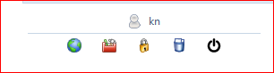

Creating/Editing Metrics and Tasks: when you create a metric, there is a quick edit window to enter metric name, format, minimum, meets, and exceeds. Once the metric has been created you can click on the pencil to add comments and trend values or open the metric to add owners and edit any other element of the metric. When you create a task, there is a quick edit window to enter the date information, then you can click the pencil and add a comment or click on the task name link and edit the full task including adding the person responsible, related links, etc. See sample metric quick edit below:

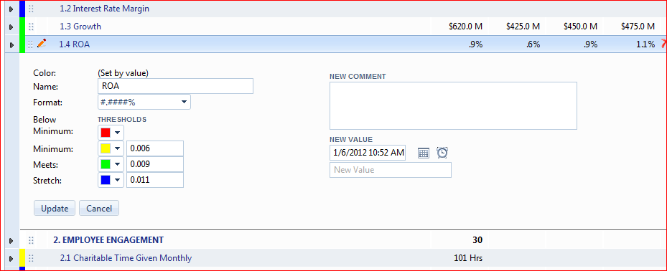
Creating/Editing Metrics (Format field): Common financial institutional formats for creating/editing metrics:
Common Credit Union Measures | Formatting Field Examples – typed in Format Field | Numeric Data to be Typed in Trend  Data Fields | How Number Displays on Org/Dept Tab
ROA | #.####% | .0097 | .97%
Percentages | #.####% | .85 | 85%
Dollars | $#,### | 4500 | $4,500

Drag and Drop: To move items you will drag and drop for metrics, projects and tasks. You will see a symbol next to the item of 6 little dots – click on the dots and just drag and drop where you want to place the item on the list.
- Drag over the bottom half of 4 to drop as 5
- Drag over 4 and hold SHIFT to drop as 4.1, or drag over the top half of 4.1 to drop as 4.1
- Drag over the bottom half of 4.1 to drop as 4.2
- Drag over 4.1 and hold SHIFT to drop as 4.1.1
- Since you are dragging 4.2 in the example, dropping on 4.2 does nothing
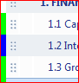

Add Project Members, Tasks and Metric Owners: opening the metric or task to the full edit page, you will see a field to add the person’s name – put your cursor at the beginning of the field and the list of users will appear in alpha order – select the person you want listed and click add or insert. On a task, it is created in the Quick Edit mode. To add a task owner, put your cursor to the beginning of the owner field and begin to type the name of the owner into the owner field (the owner should already be entered as a team member). The name will appear to select.
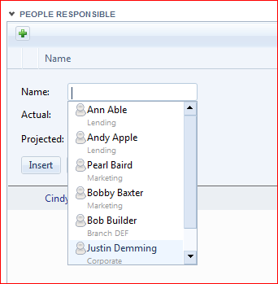

Printing Reports: The User can print the specific Tab view report by clicking on the link in the Reports module on the Organization, Department, Project or People Tabs. The navigation to other like views will be either at the top of the report or on the left side navigation tree.
At the top of the reports, you will see an Options icon to select/check the elements of the report that you want to view/print:
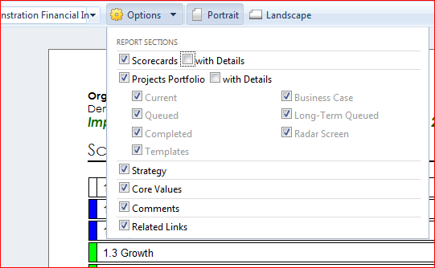

Related Links: the related link browse button has been eliminated (per security reasons; all browsers but IE do not allow any browse button capability). You will have to copy and paste the location of the document from your web folder into the Related Link URL address field. To set the link without a browse button, using Word 2010, right click on the Tool bar at the top of the page, select “Customize Quick Access Toolbar”/select All Command/From the Choose Commands drop down list, scroll down and select Document Location – highlight and click add to move it to the right column. Click OK. Now the complete path to the document will be in the upper left top of your screen, copy and paste in the URL box. Using Word 2007, click the File color symbol, select Prepare, Show Properties and you will see the complete path at the top of the document and copy and paste in the URL box.

People Tab – Basic Role and Basic Role Tasks: the Basic Role Indicators are added beneath the Basic Role. The Basic Role tasks are created and edited on a module under the Basic Role Module.
People Tab - Connected Metrics: this is a module that shows all metrics that the individual you are viewing has ownership for that are not under the individual metric module. If this person “owns” a metric in an organization or department scorecard, it will show on their page in the Connected Metrics module.
People Tab - Project Module: the projects only module lists the projects the person is a member of.
People Tab - All Tasks (Project, Dialog Follow-Up, Basic Role, and Personal): the tasks anywhere in the application that the user owns and his security to update can be seen on their People tab. The User can just click the “blue circle check” next to the task and that will mark the task as completed. Once the circle is clicked it will change to green showing that the task is completed. The “Actual end date” will be the date the circle is clicked to show that it has been completed. You can still do a quick edit and add a comment and also mark as completed by entering the “actual end date”.

All Dialogs: To create a dialog, click the green + sign icon under Dialogs. Add the name of the Dialog. Click on the dialog date link, and the dialog will open in a full web page. You will see a blank agenda box. Click into the agenda box. You will then see last month’s agenda on the right and a blank agenda to edit on the left. If you want to copy the agenda from last month (then edit it), click the green arrow in the center between the two agendas and the agenda on the right will automatically copy into the agenda on the left. You can then make any adjustments to the current agenda on the left. Click Update to save the changes. You can also create Related Links as well as Follow-up Tasks. All Follow-up Tasks that have been assigned a task owner will show up on the owner’s “people tab”.
The same procedure will work for Basic Role comments on the Individual Dialog. Click each Basic Role box as indicated by dotted lines and the edit function appears. You can use past comments by clicking the green arrow or update comment in comments section. Click Save Note. Follow these insutrctions for each Basic Role/Key Results area.

Support Community – For support help, bug reports, feature requests, comments (we are interested in your feedback) and forums click on the “Support Community” link at the bottom of the page (right click to open in a new tab). This Zendesk site shares logins with Connections Online. If you have a Connections Online account, you can log in with it here too! Here is a link for instructions on our Zendesk support site: http://www.connectionsonline.net/docs/NewSupportSite-Zendesk.pdf
To use email to submit a ticket, email your support question to support@connectionsonline.net. (You must be logged in as a Connections Online Support User – do this by logging into Connections Online, then clicking Support Community at the bottom of the Connections page. Just logging in once allows you to always use the email: support@connectionsonline.net for future tickets.) Once email is submitted (or ticket created through the Support Community link) you will be notified through email of any updates or answers to that ticket.

Connections Online and the IPad2: although we are not officially supporting Connections Version 4.1 with the IPad2, I have found that it works pretty well. In limited testing, I discovered the drag and drop does not work. Also, if a link doesn’t open the page immediately when you touch it (i.e. Dialogs), hold your finger down onto the link and an edit box will pop up. The top line of the edit box says “Open” – click open and the web page will open. To see the pencil to edit an item, click the row where the item is on the IPad, you will now see the pencil edit symbol – click the symbol and you will be able to edit the item. For checking off a task – click the task row, then click the circle to mark off as completed and the circle will turn green to show that it has been marked off.

Notes:
- IE 8 and above: Turn OFF Compatibility mode (to make sure your compatibility mode is turn off, open browser, click Tools, select Compatibility View Settings, if connectionsonline.net is on the list, highlight and click remove) If compatibility is “on” in IE8, some of the modules aren’t sized properly on the page (they may look a little squished)

Demo Videos for Navigating and Editing: https://files.connectionsonline.net/files/Training%20Videos/videos-links.docx
- COL Introduction
- Logging In
- Setting Passwords
- Navigation/Search
- General Editing
- Metric Overview
- Creating a Metric
- Project Overview
- Creating a Project
- Create/Edit Project Tasks
- Project Reporting
- People Tab Overview
- My Tab
- Reporting Intro
- Dialogs
- Activity Report
- Advanced Features Webinar
- Application Training Webinar
- Security Training Webinar

